

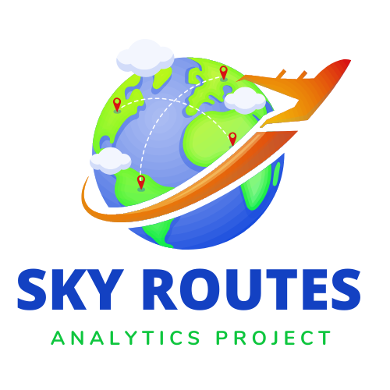

**Project name:**

SKY ROUTES ANALYTICS PROJECT

**Project description:**

This project analyzes passenger flow at US airports and cities using flight data from 1993 to 2024. The analysis will help estimate the number of passengers who will use the arrival and departure halls at different airports, which will contribute to improving the infrastructure to be able to better accommodate passengers. SQL will be used to extract and clean big data, and Excel to analyze passenger flows and create reports and insights.

**Project objectives:**

* 1. Analysis of passenger flow at different airports over the years.
  2. Estimate the number of passengers for each city or airport to identify places that need infrastructure development.
  3. Study seasonal and annual patterns of passenger flow.
  4. Providing reports and graphs showing the areas that require improvement in the arrival and departure halls.

**Basic steps of the project:**

1. Import and manipulate data using SQL:

* Import flight data from CSV file to SQL database.
* Clean data and remove missing or illogical values ​​such as negative passengers or invalid values.

1. Passenger flow analysis using SQL:

* Estimating the number of passengers at each airport and the extent of use of the arrival and departure halls.
* SQL query to count the number of passengers for each airport
* Passenger analysis for each city

1. Analyze data using Excel:

* Export results from SQL to Excel for deeper analysis.
* Use pivot tables to analyze passengers based on airports and cities.
* Divide the analysis into time periods (months or years) to understand the seasonal flow of passengers.

1. Create graphs:

* Create graphs showing passenger flow throughout the year and passenger volume for each airport or city.
* Analyze seasonal patterns to determine periods with the highest passenger flows.

1. Recommendations for infrastructure development:

* Preparing a report showing which airports and cities need infrastructure development based on passenger flow.
* Providing recommendations such as expanding arrival and departure lounges in the busiest airports or adding new lounges in areas experiencing an increase in the number of passengers.

**Tools used:**

1. SQL
2. Excel
3. Python
4. Tableau